HOLWELL SPORTS BOWLS CLUB
SEASIDE & SCENERY TOUR 2024 OF SUFFOLK & ESSEX

THE 4* MILL HOTEL. SUDBURY SUFFOLK
A beautifully converted watermill with original water wheel nestled on the banks of the River Stour next to lush green water-meadows and framed by weeping willows.

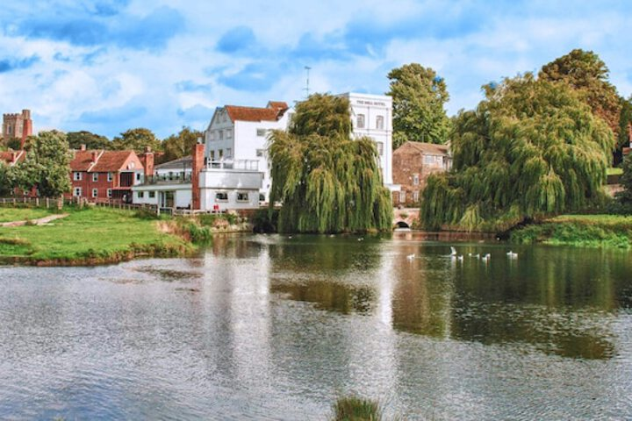
Monday 2 September – Friday 6 September 2024
You are cordially invited to accompany President Bob on his tour of Suffolk and Essex
4 tour games are arranged in Braintree, Colchester, Felixstowe and Frinton on Sea.
The cost of the 5 days will be £430 per bowler and £420 for non-bowlers.

A deposit of £60 per person is required by 30 November 2023
FINAL Balance is due no later than 3 July 2024

Fun and games for players and tourists.
 -------------------------------------------------------------------------------------------------------------------------- Please return this slip with deposit of £60pp by 30 November 2023
Name (players) …………………………..……………….. Name (non players) ………………………..………………….
Address …………………………………………………..………………….……………………. Post Code ….……………………
Email address …………………..…………………….. Telephone ………..…………… Room - Single/Twin/Double

RSVP Bob Penny robert.penny@tiscali.co.uk 37 Carnegie Crescent. Melton Mowbray LE13 1RP. Please make cheques payable to Holwell Sports Bowls Club

