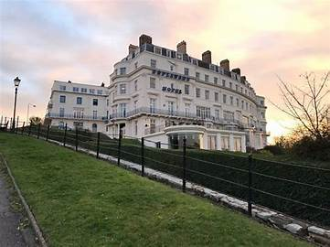
You are cordially invited to accompany President Sue on her Tour to Scarborough
Wednesday 3rd September to Sunday 7th September 2025
The hotel is in a commanding location overlooking Scarborough sandy beach and Harbour.
Breakfast: 8.30am. Dinner: 6.30pm / 7pm. Live entertainment /bingo
The cost of the five days will be £ per person Bowlers and £ NON Bowlers
FINAL Balance £300-00p per person required no later than 10th July 2023
£per person NON Players.
£ per person Deposit Required
Case Labels and Pick-up times from Oakham, Melton, Asfordby to follow.

Three six rink Mixed games of Bowls have been arranged at

NOTE: GDPR Data will only be held within A B Bowls Tours and NOT Externally known to others

---------------------------------------------------------------------------------------------------------------------------------------------------Holwell Sports B.C. 2025 President Sue’s Tour to Scarborough
Please return the slip with Deposit

Name/s_ _________ _Non/ Player/s_____________________________

Address Post Code_____________
Email address .
_________________________________________________________Telephone______________________
Single / Twin / Twin Sharing /Double
_______________________________________________________
Your Deposit by October Please = £ per person

